PROBABILITY – Task/homework Name:___________________
QUESTION | ANSWER
1. Write an example of an event that is unlikely to occur today.

2. Draw a line to match each word to a place on the number line.

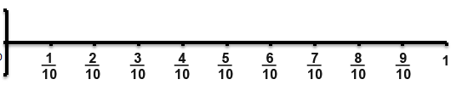

certain even chance

3. List the sample space for a 6-sided die.

4. A cheer squad has 10 t-shirts.
Each shirt has ONE of the letters of MOOLOOLABA printed on it.
A cheer squad member takes a shirt randomly from the box they are kept in.

What is the chance that the cheer squad member takes one of the shirts with an “O” on it?
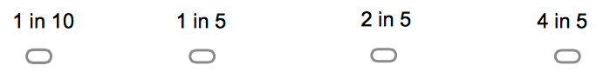
5. A bag contains counters in the following colours:
Blue | 8
Yellow | 5
Red | 9
If a counter is drawn at random, find the probability that it is not yellow.

6. Look at the spinner to answer the question.  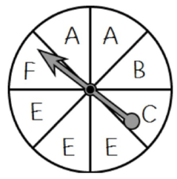  (HINT: Vowels = A, E, I, O, U) | What is the probability, as a fraction, that the spinner will land on a vowel?
7. Use the spinner to answer the questions.  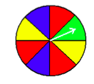 | a) P (I will spin a red) = _________ %  Complementary event:  b) P ( ) =
8. Rachael asked 100 coffee drinkers whether they like milk or sugar in their coffee.

Using the diagram below to answer the questions:
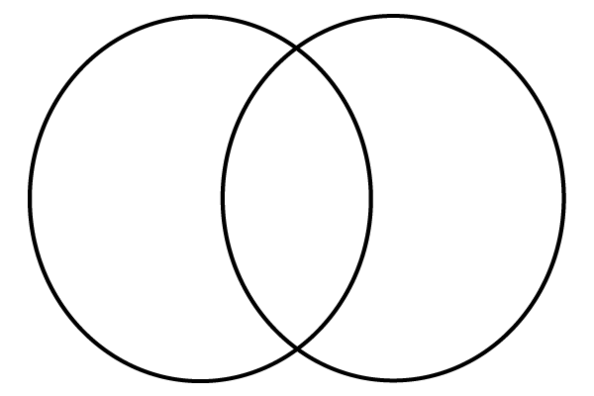
Sugar
22
26
35
Milk
a) How many people like milk? a)

b) How many people like sugar? b)

c) How many like sugar but not milk? c)

d) How many like milk and sugar? d)

e) How many people don’t like milk or sugar with their coffee? e)

9. The chance of Year 8 receiving their laptops this week is 72%.

What is the chance that Year 8 will not receive their laptops this week?

10. Decide whether the event is ‘mutually exclusive’ or ‘non-mutually exclusive’:

- A number card will be chosen. A spade will be chosen.

__________________________________________

- A red card will be chosen. A black card will be chosen.

___________________________________________

11. In the space below, complete the Venn Diagram with the number of members for each set in the appropriate place.

Twenty-seven students were surveyed about their laptop (L) or iPad (P) use.


L
P
iPad users = 13

Laptop users = 17

iPads only = 6

Neither iPads/Laptops = 4

12. Teachers were surveyed to find out their travel plans. The results were:

 | Going to Darwin | Not going to Darwin | Total
Going overseas | 15 | 55 | 70
Not going overseas | 47 | 3 | 50
Total | 62 | 58 | 120

How many teachers were:

a) Not going overseas? _______________

b) Going overseas? _______________

c) Going to Darwin? _______________

d) Not Going overseas or Darwin? _______________

e) Going overseas or going to Darwin or both? _______________

